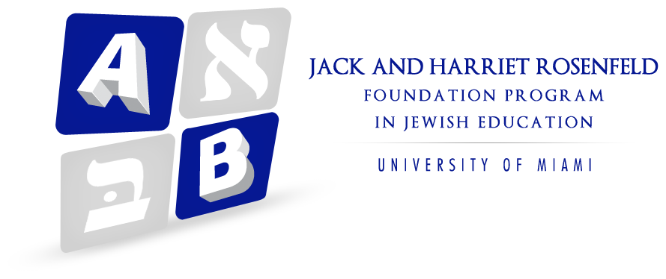

The Jack and Harriet Rosenfeld Foundation in Jewish Education

The Jack and Harriet Rosenfeld Foundation in Jewish Education at the University of Miami School of Education and Human Development was established nine years ago with a monetary gift and the mission to enhance Jewish education so that this generation of Jewish children, and generations to come, learn of the remarkable legacy of Judaism, its contributions to all aspects of life, and its moral and ethical principles that have shaped the world.
The Jack and Harriet Rosenfeld Foundation in Jewish Education identified a gap in Jewish education resources and made a commitment to create a single pluralistic, navigable database of quality educational resources. JewishLearningMatters.com (JLM) is an innovative project that strengthens the scope, reach and depth of Jewish education and meets expectations of a rising generation of Jewish students growing up in the digital age.
JLM is a dynamic, growing website supporting educators as they create and update curricular materials and teaching strategies in a manner consistent with 21st century teaching and learning. The website includes a searchable bank of peer-reviewed resources including: lesson plans, book units, songs, stories, projects, crafts, videos, and research-based strategies and “teacher tools” to extend and expand learning in Jewish thought, text, values, and history. JLM is a change maker that encourages and enables users to connect, collaborate, and contribute in a digital world.
With over 2,500 resources, JLM has already impacted educators in academically and geographically diverse Jewish educational communities around the globe. While there are websites available to support Jewish education, the following benefits are unique to JLM:
- JLM’s database and advanced search functionality allow educators to quickly access a variety of interdisciplinary resources to explore and reinforce concepts in Jewish values, holidays, Hebrew Bible, history, prayer, customs and traditions.
- Each resource is carefully evaluated for quality, accuracy, educational value, age appropriateness, focus, and ability to deliver education through a Jewish lens.
- JLM users can review, offer ideas or ask questions for modifying and adapting resources for their specific needs.
- JLM has forged relationships with organizations including The Anti –Defamation League (ADL), Jewish Women’s Archives, Learning to Give, Keshet, Jewish Partisan Educational Foundation, Facing History and Ourselves, Institute for Curriculum Services (ICS), PJ Library and the iCenter and is reaching out to other Jewish organizations around the country to cross-link, share content and enhance marketing opportunities.
The JLM user and content base have grown through a combination of presentations and workshops at local and national conferences and a social media marketing strategy that recruits users through our curation of relevant social media resources. In only a few years, JLM has exceeded initial goals by engaging over 125,000 users throughout U.S., Israel and 150+ other countries.
To fulfill its enormous potential to transform teaching and learning, JLM proposes to:
- Connect and forge a relationship with teachers and students in Israel, to foster students an understanding and respect for Israel, its people, culture, and society.
- Develop a module to provide educators with a step-by-step guide to customize curriculum, allowing them to create, save and share teaching plans using the vast options in the JLM database.
- Help create and support teachers through in-service workshops, on-line tutorials, and meeting teachers through on site visits as well as through on-line support and skype.
- Expand resources of JLM database for educators in early childhood through high school in formal and informal settings and expand relationships with additional Jewish organizations, nationwide.
- Continue to improve Search Engine Optimization (SEO) and AdWords as well as a more coordinated Social Media Strategy to increase JLM’s reach, reputation and content.
- Create newsletters and resource roundups (blogs) that are posted on JLM, Facebook, and sent to thousands of individuals on our distribution list. These materials focus on Jewish thought, life, history, values, and tradition as well as on current events and topical issues relevant to our communities.

In addition to the initiatives described above, the Rosenfeld Foundation also supports professional school development workshops. Our annual Ethics institute, now in its sixth year, brings experts from around the country to support teachers as they address issues and topics such as: Service Leaning (Civic Responsibility), Jewish Identity, Character Development, Bullying (including cyber bullying), and "Nurturing the "The Resilient Child" These institutes reach hundreds of teachers each year in the Jewish Day Schools and Congregational schools throughout South Florida.

Finally, the Rosenfeld Foundation is in the planning stages of a new initiative, The Imagine Project, dedicated to “Creating a Culture of Kindness.” The words of Martin Luther King have inspired this effort and its direction: "Men often hate each other because they fear each other; they fear each other because they don't know each other; they don't know each other because they cannot communicate; they cannot communicate because they are separated.” –Martin Luther King

Mission:

- To create a multi-faceted outreach program to unite people of different diverse backgrounds--cultural, religious, sexual, and gender orientation through authentic learning opportunities that will allow them to know one another

- To encourage communities to “Imagine” ways they can bring “kindness” to the forefront of curriculum and develop action plans for “living kind”

- To promote in both Jewish and non Jewish students a deeper understanding and appreciation of Judaism in terms of our history, values, thought, and tradition

